**MOCK UP:**

**HOMEPAGE UI DESCRIPTION**

**The homepage will look like this:**

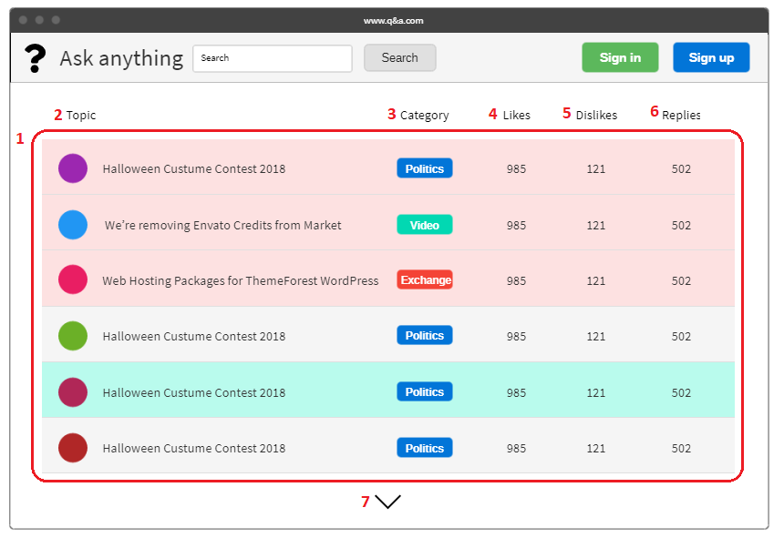

1: List of question topics sorted by decreasing time is displayed on the screen.

2: Column containing topics.

3: Column containing types.

4: The column contains the total number of likes by each topic/question.

5: Column contains the total number of dislikes by each topic/question.

6: Column contains the total number of answers to each topic/question.

7: “Show more” button.

**Each topic will be showed as a row in the list:**



1: Avatar of a user who created the question.

2: Title of the topic/question.

3: Name of the category. Each category has one color.

4: Number of likes on that topic/question.

5: Number of dislikes on that topic/question.

6: Number of anwers on that topic/question.

**HOMEPAGE BEHAVIOUR DESCRIPTION**



1. Click on the avatar: Website will navigate to this account’s personal page.
2. Click on the title: Website will navigate to this specific topic page.

**USECASE DESCRIPTION**

|  |  |
| --- | --- |
| **Use case name** | View Homepage Screen. |
| **Description** | Allows user to view home page and perform actions on the screen. |
| **Actor** | User, guest |
| **Pre-conditions** | None |
| **Post-conditions** | None |
| **Normal Flow** | 1. Users access to the website. 2. Homepage screen appears. |
| **Alternatives** | None |
| **Exceptions** | None |

|  |  |
| --- | --- |
| **Use case name** | View Other Users Personal Page. |
| **Description** | Allows user to view basic information about the account which user clicked on. |
| **Actor** | User, guest |
| **Pre-conditions** | User is staying at Homepage Screen. |
| **Post-conditions** | User will be nevigated to this account’s personal page. |
| **Normal Flow** | 1. User clicks on the avatar of the account. 2. The Personal Page account will be showed on the screen. |
| **Alternatives** | None |
| **Exceptions** | None |

|  |  |
| --- | --- |
| **Use case name** | View Specific Topic Page |
| **Description** | Allows user to view the specific topic with answers which user clicked on. |
| **Actor** | User, guest |
| **Pre-conditions** | User is staying at Homepage Screen. |
| **Post-conditions** | User will be nevigated to this specific topic page. |
| **Normal Flow** | 1. User clicks on the title of the topic. 2. The Topic Page will be showed on the screen |
| **Alternatives** | None |
| **Exceptions** | None |